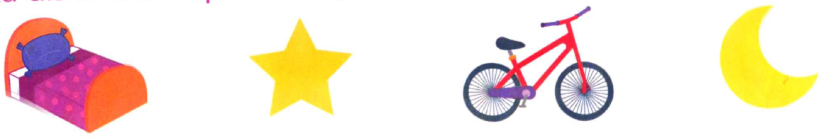Le son /l/

|  |  |  |  |
| --- | --- | --- | --- |
| lit | étoile | vélo | lune |
| lit | étoile | vélo | lune |

*  **Colle la syllabe que tu reconnais.**
* **Colle les lettres pour écrire le prénom du personnage :**

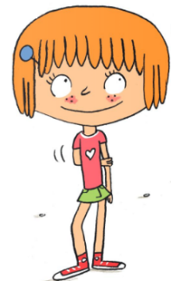

|  |  |  |  |  |
| --- | --- | --- | --- | --- |
|  |  |  |  |  |

…………………………………………………………………………………..

le li lu lo le le le la la

* **Lis les phrases.**

|  |  |  |  |  |  |
| --- | --- | --- | --- | --- | --- |
| Sami | regarde | la | lune. |  |  |
| Julie | a | un | vélo. |  |  |

* **Colle le ou la devant chaque dessin.**

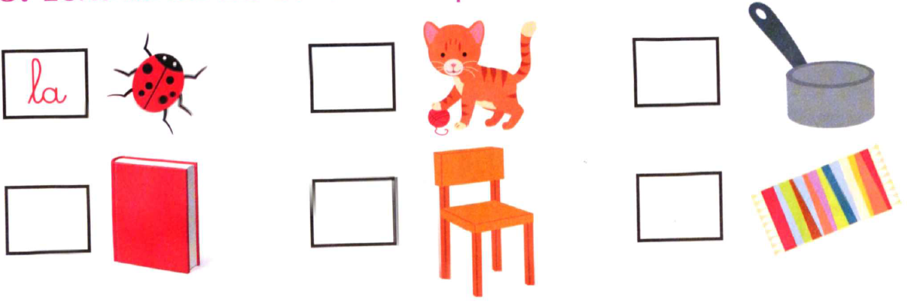

|  |  |  |  |
| --- | --- | --- | --- |
| vé | lo | li | vre |
| lu | ne | ju | lie |
| li | ya | é | toi |
| la | ly | li | am |
| la | sso | le |  |

|  |  |
| --- | --- |
|  |  |
| vé | lo |

|  |  |
| --- | --- |
|  |  |
| li | vre |

|  |  |
| --- | --- |
|  |  |
| lu | ne |

|  |  |
| --- | --- |
|  |  |
| la | ly |

|  |  |
| --- | --- |
|  |  |
| li | ya |

|  |  |
| --- | --- |
|  |  |
| li | am |

|  |  |  |
| --- | --- | --- |
|  |  |  |
| é | toi | le |